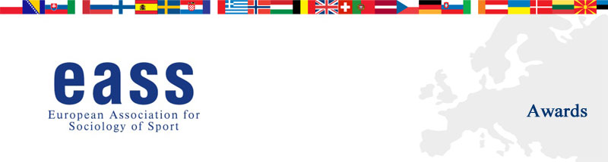

Young Researcher Award 2018 –CALL FOR PAPERS
The European Association for Sociology of Sport is proud to announce the 10th Eass Young Researcher Award. The aim of the award is to facilitate the integration of outstanding graduate students and young researchers into the European community of sociology of sport scholars. The award will be granted to a scholarly paper authored by a young researcher, which is deemed by a panel of judges to be of highest quality. The winning author will be invited to receive the award and present the paper at the Annual Conference of the Eass, to be held in Bordeaux, France, 23–26 May 2018. The winning paper may be considered for publication in the European Journal for Sport and Society.
DEADLINE FOR RECEIPT OF SUBMISSIONS: 31st January 2018
Selection Committee 2018:
Professor Michael Atkinson (University of Toronto), Dr Louise Mansfield (Brunel University), Dr Kim Wickman (Umeå University), Dr Davide Sterchele (Leeds Beckett University).
All papers should be sent to Dr Davide Sterchele at d.sterchele@leedsbeckett.ac.uk
Eligibility:
- Any student who is registered for master or doctoral level graduate work at the time her or his paper is submitted.
- Any researcher, younger than 35, who was awarded PhD not earlier than 5 years before the time her or his paper is submitted.
- The committee will accept only one submission per author.
Awards:
- The winning author will be invited to attend the Eass conference free of charge and to present the paper to the plenary session during the closing ceremony.
- Eass sponsored prize of membership in Eass for the year after which the award is granted.
- The panel of judges may also give one honourable mention. Young researchers receiving an honourable mention will also have their papers accepted for presentation in a parallel session at the Eass conference free of charge.
- Additional monetary prizes may be indicated in the forthcoming announcements of the Eass conference.
- The name of all winning authors will be posted on the Eass website (see: http://www.eass-sportsociology.eu/award-winners/)
Requirements:
- Candidates will submit a scholarly paper on a topic that is of interest to the European sociology of sport academic community. Please submit two separate files: the first one must contain the title of the paper and the full contact information of the author; the second one must contain the title, the abstract and the full text of the paper (here the author should remain anonymous).
- Papers with a length of over 8,000 words (references included) will not be considered.
- Papers must be original, i.e. not already submitted elsewhere.
- Authors will submit a letter, signed by her or his academic advisor, verifying their student status or the date of their PhD dissertation (not earlier than 5 years before the time her or his paper is submitted).
- Authors will comply with the publications guidelines of EJSS
(see: http://www.tandfonline.com/action/authorSubmission?show=instructions&journalCode=ress20)
- Papers should be sent to the Award Committee Chair in electronic copy (Microsoft Word).
- When sending the full paper for the YRA, those authors who plan to attend the conference regardless of the YRA results must also submit their abstract separately via the on-line submission system of the general conference.
For any enquiry, please contact Dr Davide Sterchele: d.sterchele@leedsbeckett.ac.uk
Further information about the Award at: http://www.eass-sportsociology.eu/awards.html

